Prototype Document

**Product**: AI Co Founder for E Commerce (ShopPilot)  
**Version**: 1.2  
**Date**: 28 September 2025

# 1. Introduction

The prototype shows how the AI Co Founder system works in practice. It is not a full production system but it demonstrates the main features that we plan to build. The prototype is useful for testing early ideas, showing value to stakeholders, and preparing the next development stages.

# 2. Purpose of the Prototype

The main purpose is to provide a simple but functional model of the AI Co Founder system. It allows solo entrepreneurs and small business owners to see how they can use conversational AI to run parts of their online store. The prototype focuses on cart recovery as the first main feature and includes small previews of inventory, marketing, and content functions.

# 3. Scope

The prototype works with:

* A web dashboard created using React and Tailwind CSS
* A backend written in Node and Express for authentication and data management
* An MCP server built with FastAPI to handle AI tools
* n8n running in Docker to manage automation workflows
* Local LLMs through Ollama for content generation and analysis

The system connects only to test data, Shopify developer accounts, or CSV files. No production stores or live payments are connected.

# 4. Architecture of the Prototype

The prototype is built on a layered design:

* **Frontend**: a simple dashboard with chat interface and metric tiles
* **Backend API**: handles login, data requests, and job management
* **MCP Client and Server**: provides tools for cart analysis, template generation, and campaign reporting
* **n8n Orchestration**: runs workflows that link cart events to email messages
* **External Data Sources**: Shopify test store, Klaviyo test account, and CSV data

**[Insert prototype system diagram here]**

# 5. Features Implemented

* Conversational chat that routes user commands to agents
* Dashboard with basic metrics such as cart abandonment and recovery rate
* Cart recovery flow that fetches test carts, generates recovery messages, and simulates email sending
* Simple inventory view with test data showing stock levels
* Content generation demo for product descriptions
* Marketing campaign demo with fake engagement data
* Settings page for basic preferences and brand tone

# 6. Data Used in the Prototype

The system does not use real customer data. Instead, it uses:

* Test carts with sample products like handmade soap
* Fake customers with example emails and phone numbers
* Sample inventory data stored in CSV
* Generated templates and example campaigns

# 7. Ethical Safeguards

The prototype includes early safeguards such as:

* Human approval for sensitive actions like bulk emails
* Simple consent flags for customers
* Data handling that follows the spirit of GDPR rules
* Logs of actions taken by agents for later review

# 8. Limitations

The prototype has several limits:

* No connection to live e commerce systems
* No support for multiple tenants or billing
* Data is not stored securely in production grade databases
* Only a few AI tools are available and most use test data
* User interface is still basic and not ready for public release

# 9. Demonstration Steps

1. A founder logs in and is guided through a simple setup wizard
2. The system imports test data with customers and carts
3. The founder opens the dashboard and sees abandoned cart metrics
4. In the chat the founder types “send promo for abandoned carts”
5. The cart recovery agent fetches cart data, generates messages, and shows a preview
6. The founder approves the send and the system simulates delivery
7. The dashboard updates with a message such as “promo sent to ten customers and two converted”

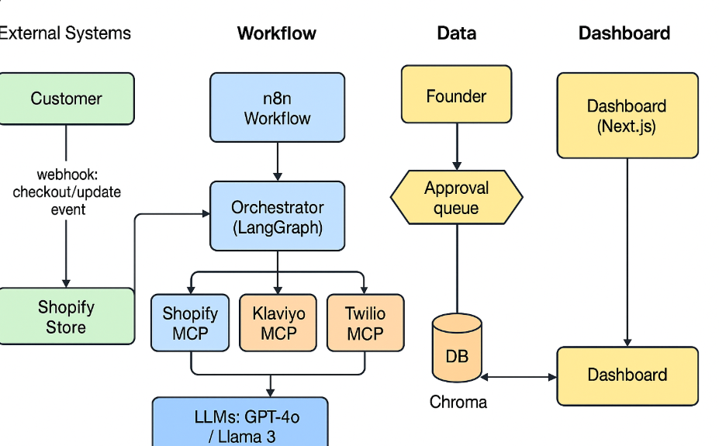

# 10. Current Results

The prototype demonstrates that cart recovery through conversational AI is possible. It shows a clear workflow from input to output and allows human approvals. It also shows that integration with tools such as n8n and Ollama works as expected in a local environment.

**11. Next Steps**

* Add full data dashboards for cart recovery, inventory, SEO, and marketing
* Connect to real Shopify and Klaviyo APIs for pilot testing
* Strengthen security and add role based access control
* Expand the agent pool with more workflows
* Improve the design of the dashboard and add accessibility features
* Conduct pilot testing with real solo founders to collect feedback